The Rmarkdown silly example

Jürgen Wilbert

12.12.2019

# header one

## header two

### header three

This is *italic* this is **bold**, and ***this is both!!!***.

An unordered list:

* Helmut
* Gerhard
* Angela

An ordered list:

1. Bush
2. Obama
3. Trump

Combined:

1. Sour
   * Lime
   * Envy
2. Sweet
   * Honey
   * love

# Example

Now follow some examples. We start with some analyses on Star Wars characters.

The package dplyr has a database included.

## Starwars

The Starwars data set contains the following variables:

## [1] "name" "height" "mass" "hair_color" "skin_color"  
## [6] "eye_color" "birth_year" "gender" "homeworld" "species"   
## [11] "films" "vehicles" "starships"

Do different species have different hights?

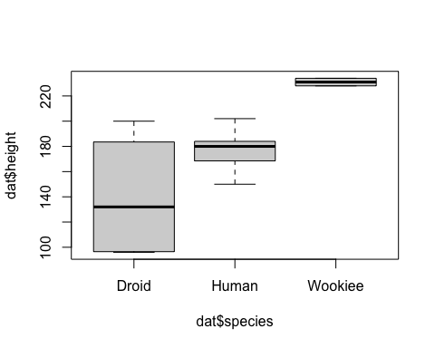

Hight distribution of Star Wars species

Is there a gender bias in Star Wars?

Gender distribution of Star Wars characters

|  |  |
| --- | --- |
| Var1 | Freq |
| female | 19 |
| hermaphrodite | 1 |
| male | 62 |
| none | 2 |

And finally, from which homeworlds do the characters come from?

|  |  |  |  |
| --- | --- | --- | --- |
|  | Droid | Gungan | Human |
| Alderaan | 0 | 0 | 3 |
| Bespin | 0 | 0 | 1 |
| Bestine IV | 0 | 0 | 1 |
| Chandrila | 0 | 0 | 1 |
| Concord Dawn | 0 | 0 | 1 |
| Corellia | 0 | 0 | 2 |
| Coruscant | 0 | 0 | 2 |
| Eriadu | 0 | 0 | 1 |
| Haruun Kal | 0 | 0 | 1 |
| Kamino | 0 | 0 | 1 |
| Naboo | 1 | 3 | 5 |
| Serenno | 0 | 0 | 1 |
| Socorro | 0 | 0 | 1 |
| Stewjon | 0 | 0 | 1 |
| Tatooine | 2 | 0 | 8 |
| total | 3 | 3 | 30 |